THINKING AHEAD
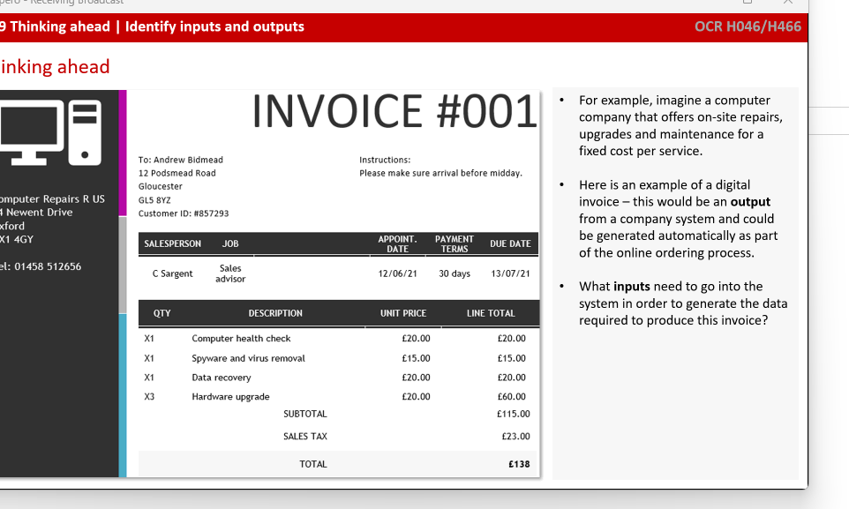
Inputs:
Number
Date
Appointments
Terms
Person

Hash table/ Linked list

Pre reading
Caching:
Computers thinking ahead, causing certain data to be able to retrieve faster
Used with web pages a lot to reduce the amount of necessary requests
If wrong data is fetched when caching, it must be flushed
This caused issues with sequencing

Pre fetching:
Requesting data before its needed
Needs a degree of certainty that this data will be required soon

